21.19: 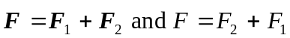 since they are acting in the same direction at 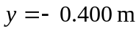so,

